

www.p3charity.org

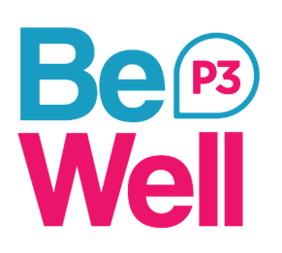

Personal Budgets
Referral Form

Please note that a copy of the Care & Support Plan and Risk Management Plans will need to be supplied to support this referral.

Throughout the form please indicate your choices with an ‘X’

Service Type

Personal Budget/Direct Payment Support
Accommodation and Support: *Stonehill Lodge, Derby
*Stonehill Lodge is a 9 bed supported living accommodation in Derby for people experiencing mental ill health with a minimum of 8 hours PB/DP support in place per week.
For more information, please contact Jane Bellamy on 07891 291060.

Service Location

Amber Valley |  | Erewash |  |  | North East Derbyshire
Bolsover |  | High Peak |  |  | South Derbyshire
Chesterfield |  | North Derbyshire Dales |  |  | South Derbyshire Dales
Derby City |  | Other (please specify)

Personal Budget/Direct Payment

Is there currently a Personal Budget or a Direct Payment in place? | Yes |  |  | No |  |  | No. of hours:

Is the support to be purchased privately? |  | Yes |  |  |  |  | No |  |  |  |  | No. of hours:
Please give details for invoicing purposes:
Eg. Derbyshire County Council, Paypacket, Disability Direct

Are you/your client covered by a Section 117? |  | Yes |  |  |  |  | No

If not, is the person you are referring aware they may have to co-fund, if applicable? | Yes |  |  | No

Details of person being referred

Title:
First name:
Surname:
Date of birth:
Tel. number:
Email:
Current address:
Postcode:

Details of Referring Agent

Name:
Organisation:
Address:
Tel. number:
Email:

Support Needs

Please detail required support.

Please provide any further information about you/the person you are referring that you feel will help us to provide support to you/ the person you are referring (eg. Language and communication needs)

Please send the completed referral form:

- Email: Be.Well@p3charity.org
- Post: P3, 7-11 Wellington Street, Ripley, Derbyshire DE5 3EH

